ASSIGNMENT – 06
Familiarisation and Usage of Cloud Services Using AWS and Open-Source Cloud Tools.

Task 01: Create a virtual machine, install and update Ubuntu.
RUN: sudo apt update and sudo upgrade -y

Now, Install Basic Utilities
Execute: sudo apt install curl wget git nano -y
This installs basic utilities required for working in Ubuntu.

TASK 02- Introduction to AWS Management Console.
Introduction:
Amazon Web Services (AWS) is a cloud computing platform that provides services such as computing, storage, databases, networking, security and monitoring.
AWS allows users to create and manage cloud resources without maintaining physical infrastructure.
Step 1: Access AWS Management Console
- Open a web browser.
- Visit https://console.aws.amazon.com/
- Sign in using an authorised AWS account.
- After successful login, the AWS Management Console home page will appear.
- Explore the home page and observe the available services.
- Locate the search bar used to find different AWS services.
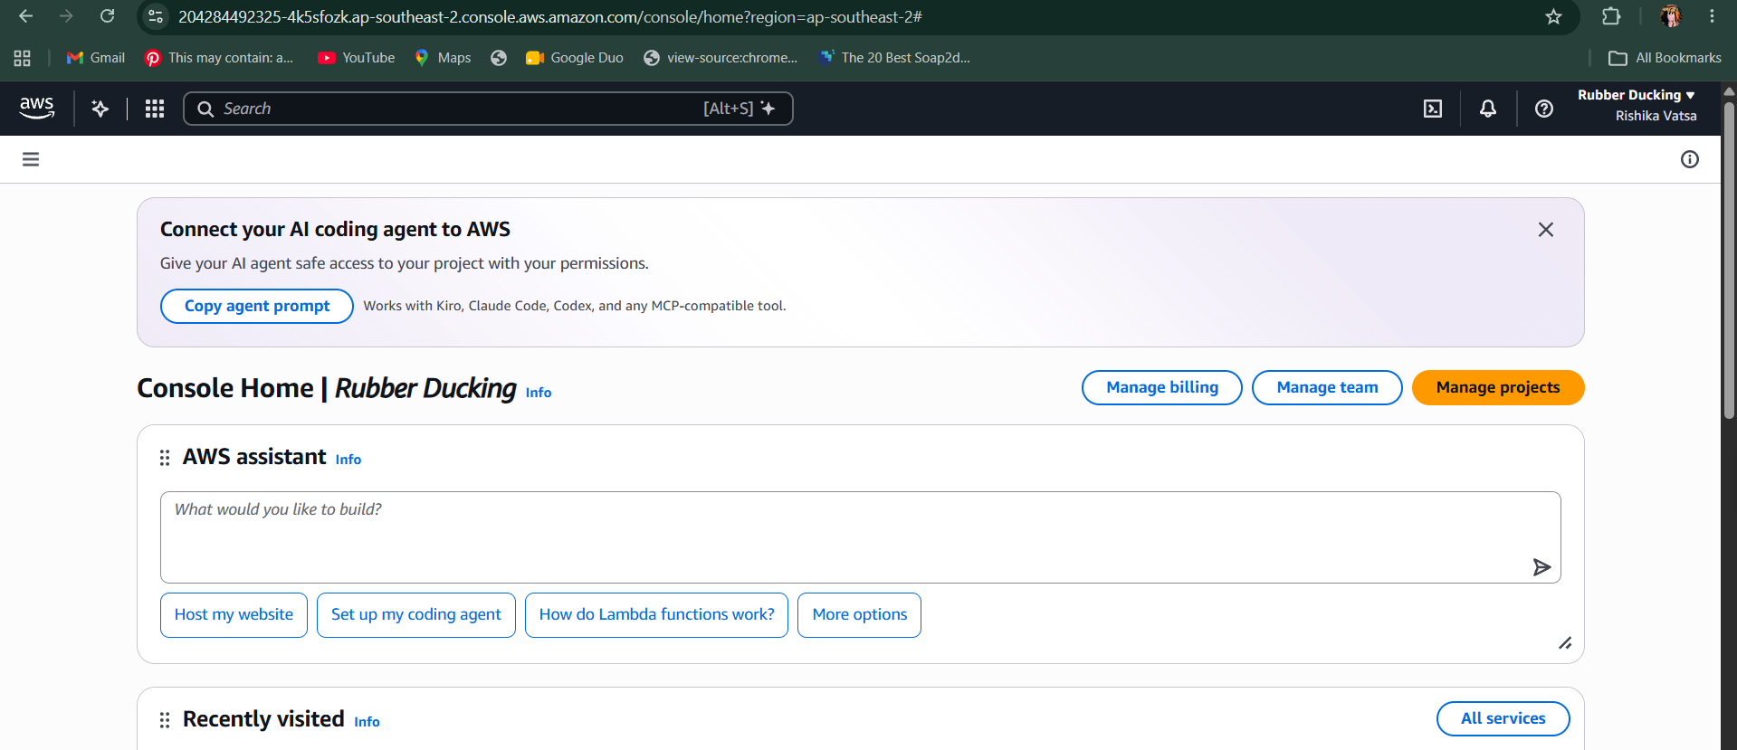
TASK 2: Implementation of Cloud Storage Using Amazon S3
Introduction:
Amazon Simple Storage Service (Amazon S3) is an object storage service used to store and retrieve data over the internet.
Step 1: Open Amazon S3
Step 2: Create an S3 Bucket
1. Enter a globally unique bucket name.
Example: cse12045-cloud-lab6-student01
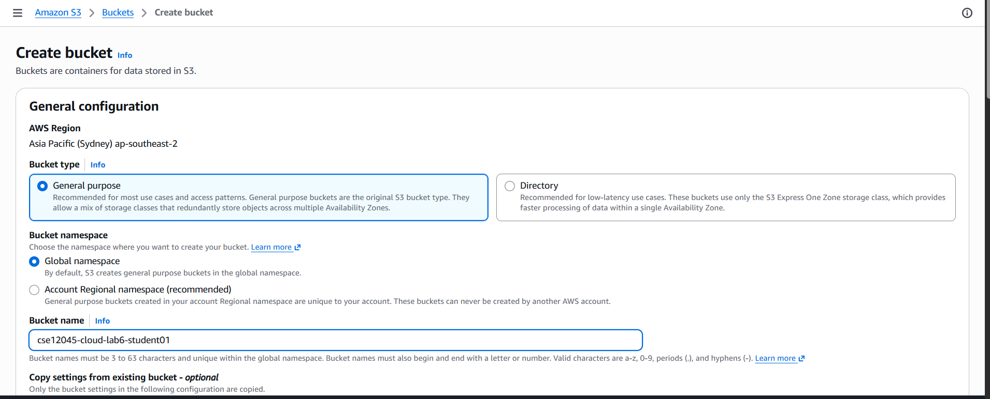
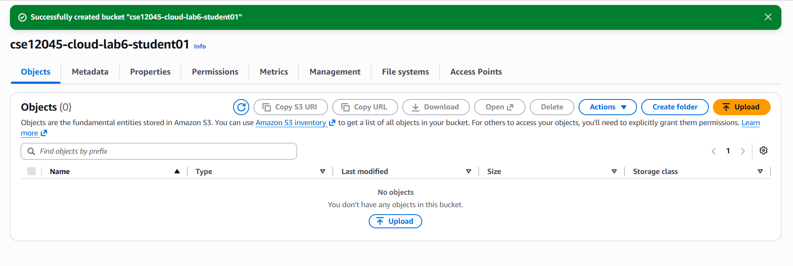
Step 03:Create a Sample File in Ubuntu
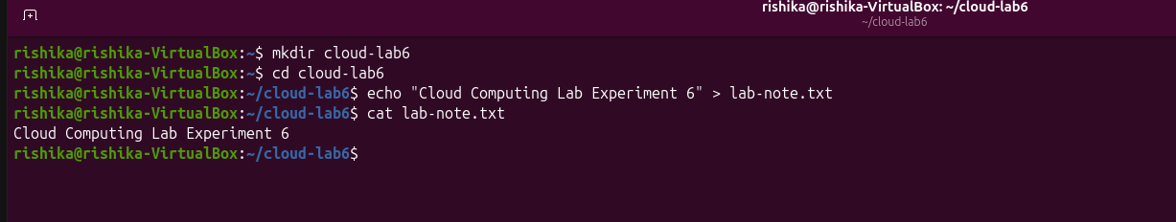
Step 04: Upload a File to S3
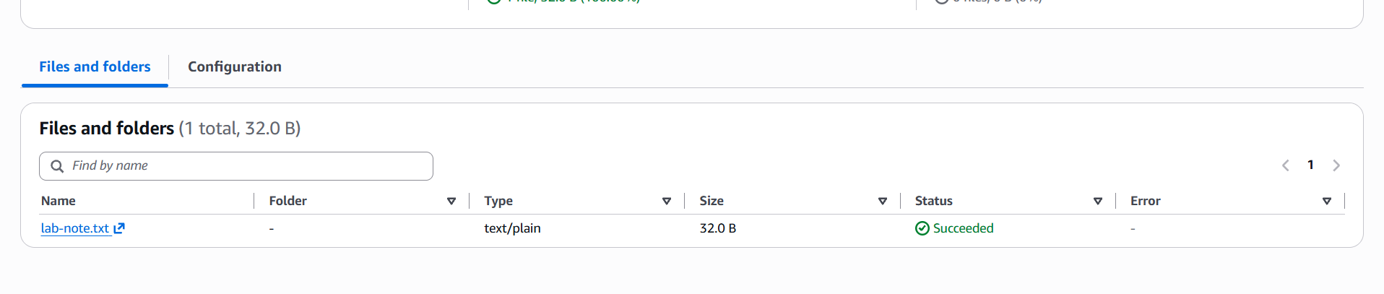
Step 5: Download the File
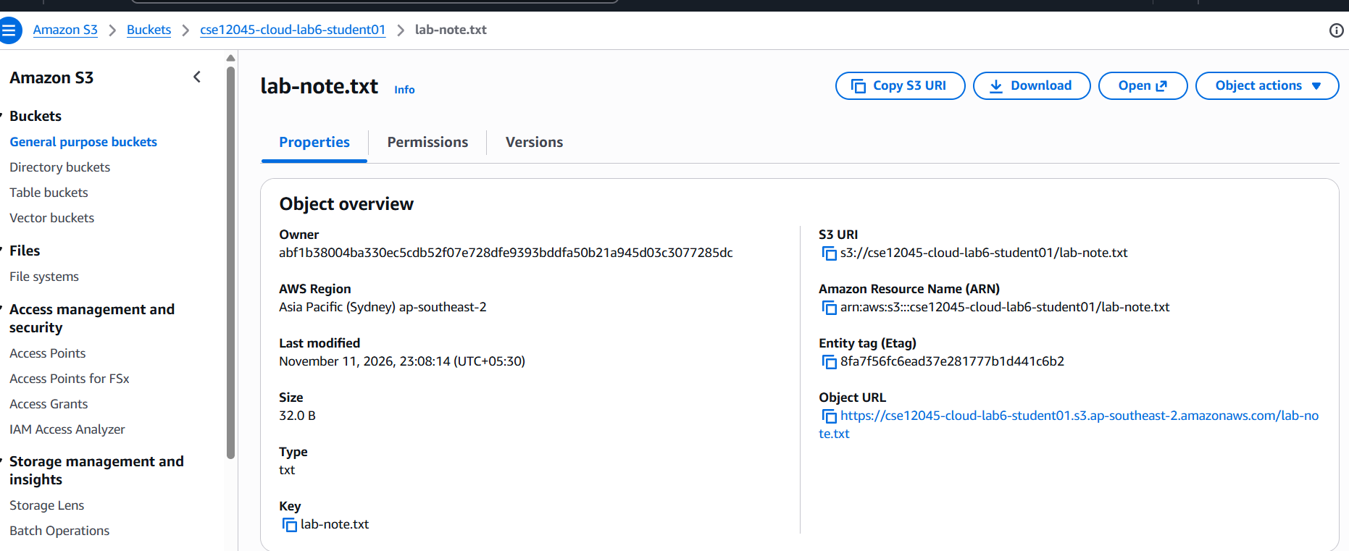
Step 6: Delete the Test Object and Bucket
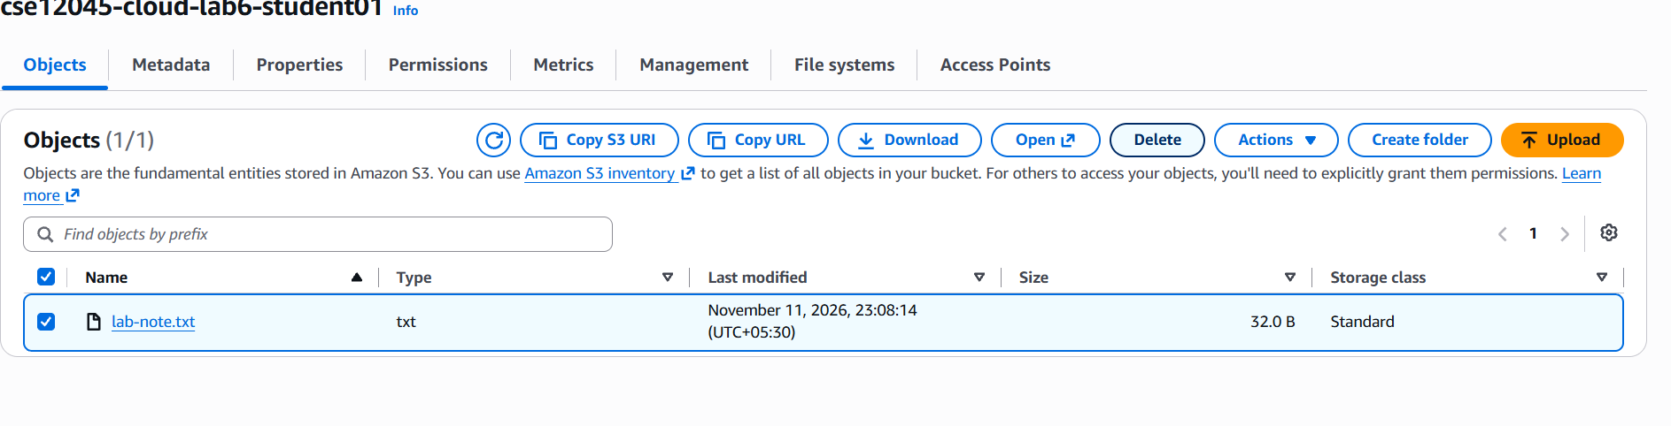
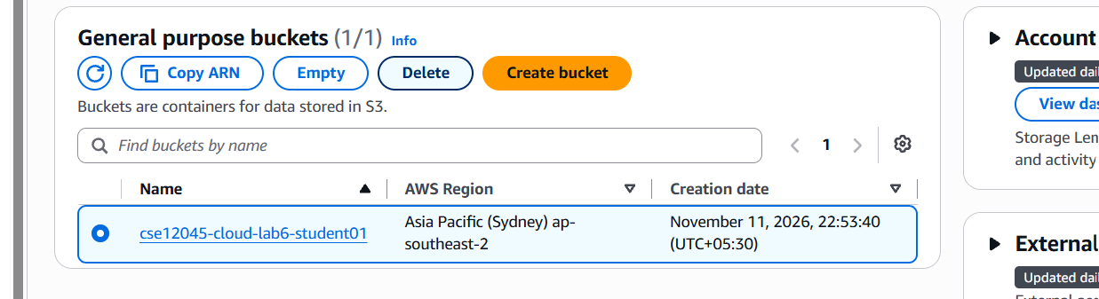

TASK 3A: Identity and Access Management Using AWS IAM
Introduction:
AWS Identity and Access Management (IAM) is a service used to manage access to AWS resources securely. It controls who can access AWS services and what actions they can perform.
Step 1: Open IAM
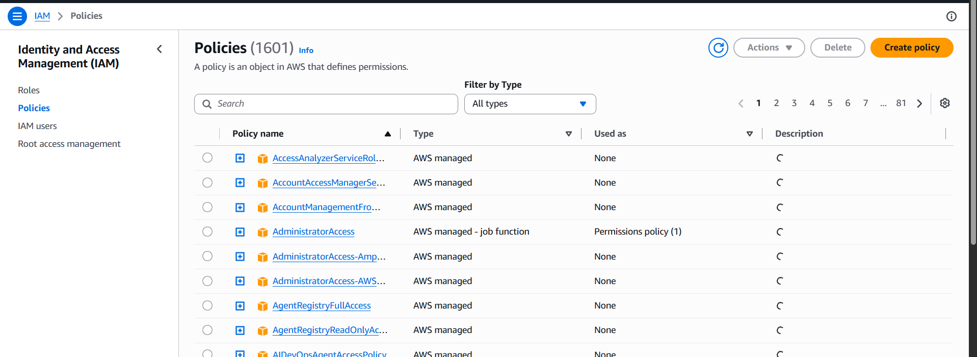
Step 2: Understand IAM Policies
Step 3: Understand the Principle of Least Privilege

Task 3B: Virtual Machine Provisioning Using Amazon EC2
Introduction:
Amazon Elastic Compute Cloud (EC2) is a cloud computing service that provides virtual servers. An EC2 instance acts like a virtual machine hosted on AWS infrastructure.
Step 1: Open EC2
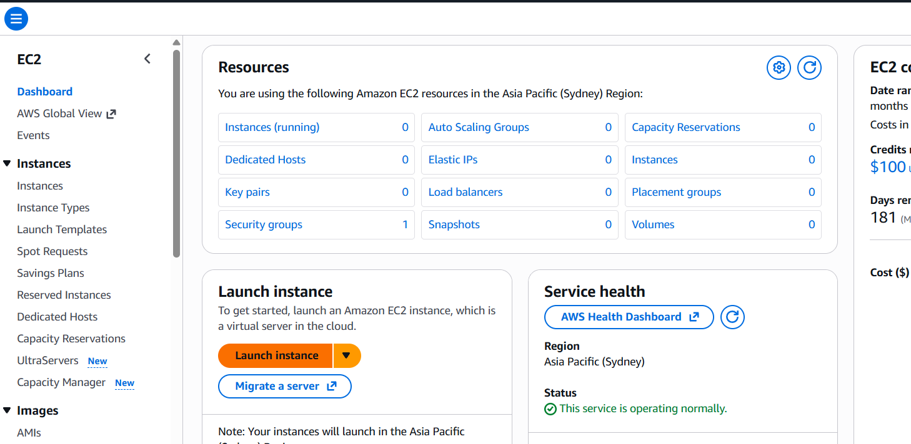

Step 2: Explore the Instance Launch Process
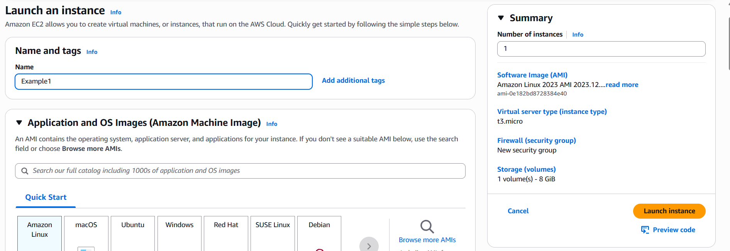

Task 4A: Virtual Networking Using Amazon VPC
Introduction to Amazon VPC
Amazon Virtual Private Cloud (VPC) allows users to create a logically isolated virtual network within AWS.
It provides control over IP address ranges, subnets, routing and network security.
Step 1: Open Amazon VPC
Step 2: Explore VPC Components
Step 3: Understand Network Communication
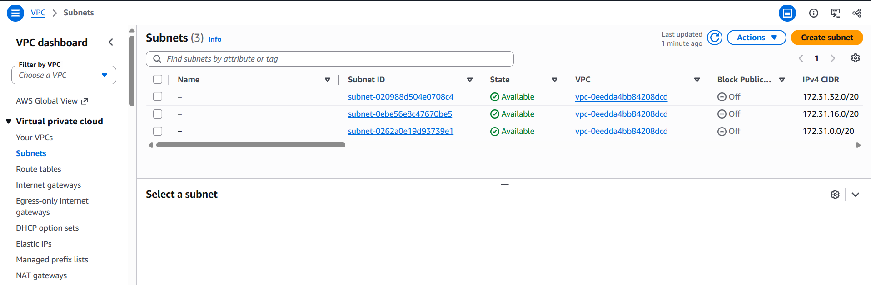

TASK 4B: Cloud Monitoring Using Amazon CloudWatch
Introduction:
Amazon CloudWatch is a monitoring and observability service used to monitor AWS resources and applications.
It collects and displays metrics, logs and other monitoring information.
Step 1: Open CloudWatch
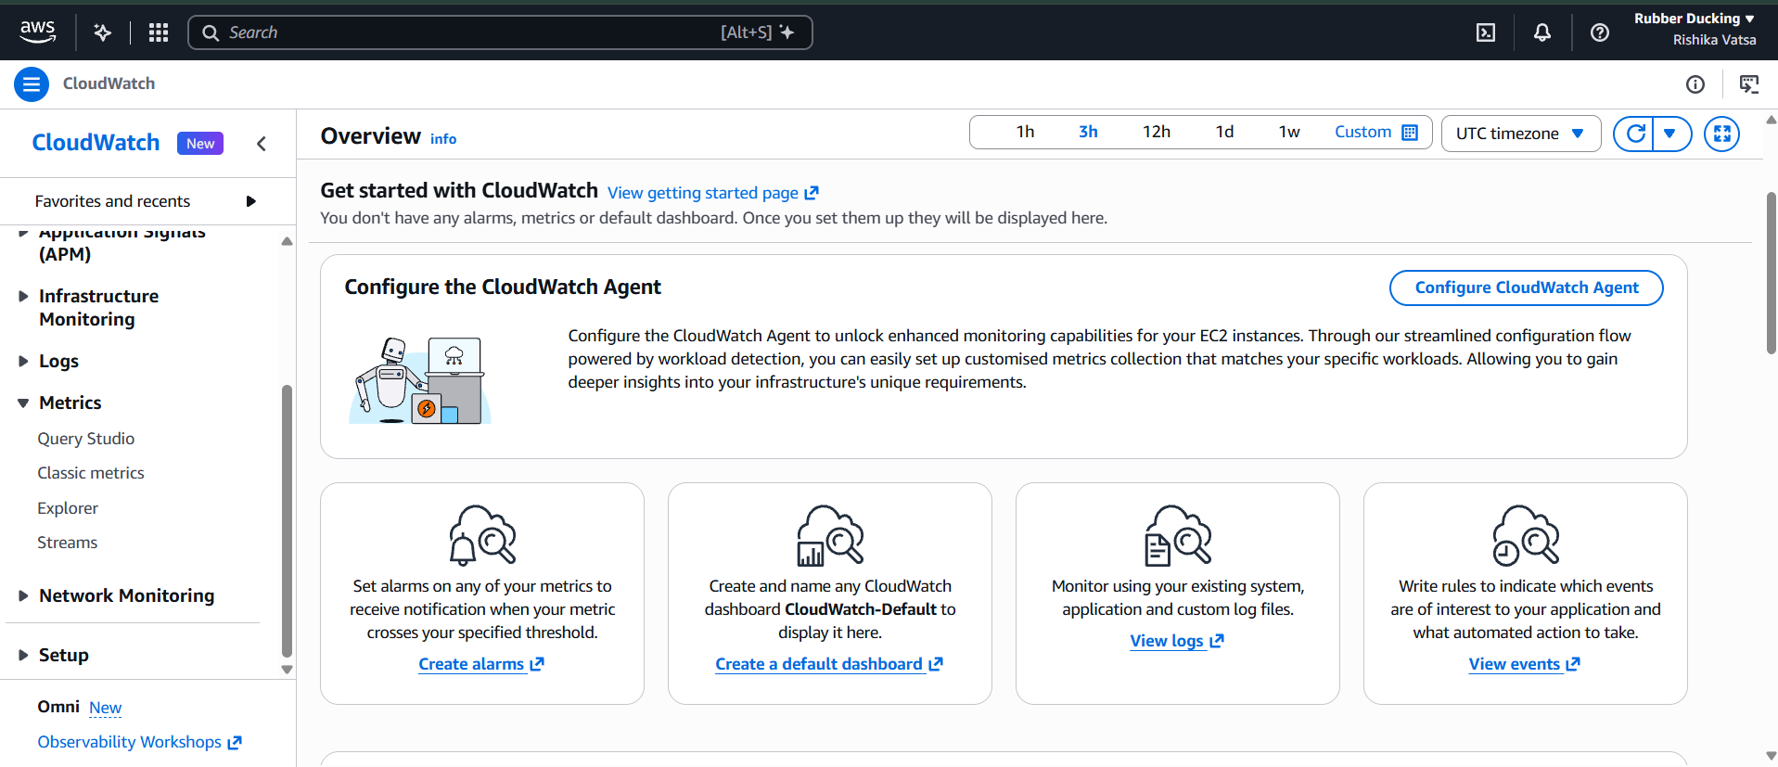
Step 2: Explore Metrics
Step 3: Explore CloudWatch Alarms

Task 4C: Basic AWS Operations Using AWS CLI
Introduction:
AWS Command Line Interface (CLI) is a tool that allows users to interact with AWS services through terminal commands.
Instead of using the graphical AWS Management Console, users can execute commands to manage cloud resources.
Step 1: Open AWS CloudShell
Step 2:Verify AWS CLI Installation – (aws -version)
Step 3: Verify AWS Account Identity – (aws sts get-caller-identity)
Step 4: List Available S3 Buckets – (aws s3 ls)
Step 5: Create a Local File – (mkdir cloud-lab6-cli -> cd cloud-lab6-cli -> echo "AWS CLI Cloud Storage Test" > sample.txt)
Step 6: Upload the File to S3 – (aws s3 cp sample.txt s3://YOUR-BUCKET-NAME/sample.txt)
Step 7: List Objects in the Bucket – (aws s3 ls s3://YOUR-BUCKET-NAME/)
Step 8: Download the File – (aws s3 cp s3://YOUR-BUCKET-NAME/sample.txt
downloaded.txt)
Step 9: Verify the Downloaded File – (cat downloaded.txt)
Step 10: Delete the Test Object – (aws s3 rm s3://YOUR-BUCKET-NAME/sample.txt)
Step 11: Delete the S3 Bucket – (aws s3 rb s3://YOUR-BUCKET-NAME)


